**Open Enrollment Instructions**

1. NAVIGATION **Menu** 🡪 **Myself** 🡪 **Benefits** - **Manage My Benefits**

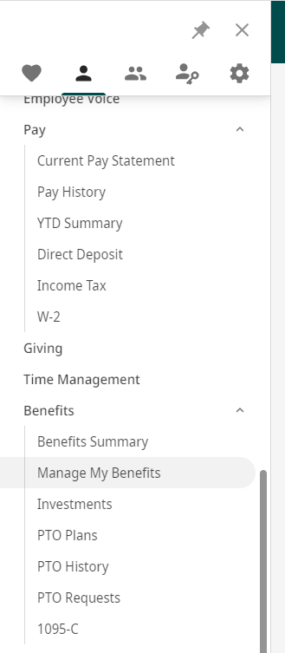

1. **Click Get Started**

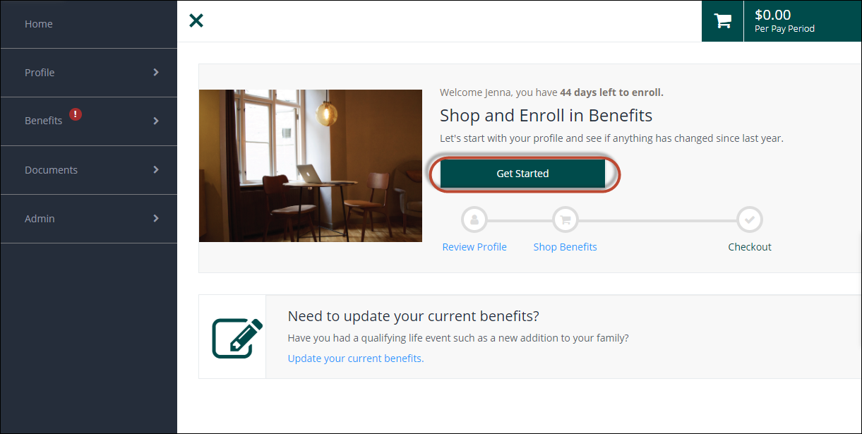

1. Manage your profile: review items to ensure accuracy

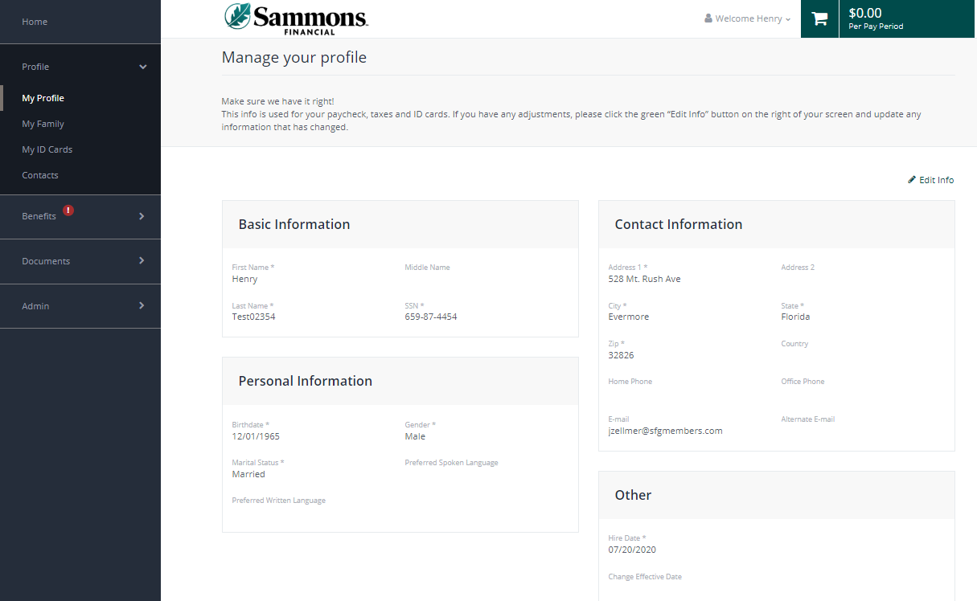

1. Bottom of page click, Next: Review My Family



1. Review and add family members for benefit coverage 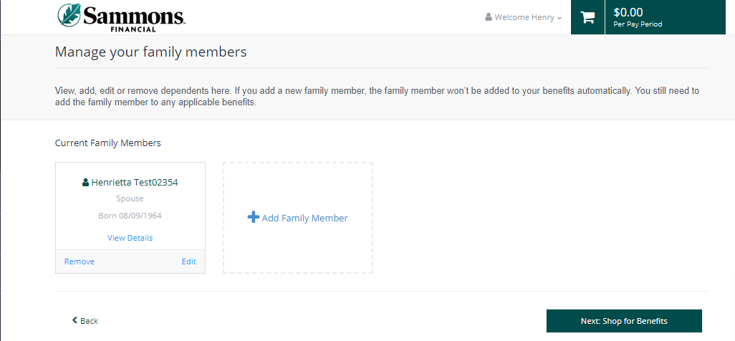
2. **Time to Shop Benefits!** Begin by clicking ‘Shop Plans’ next to Medical. Click on View Plans or Compare to make a selection.

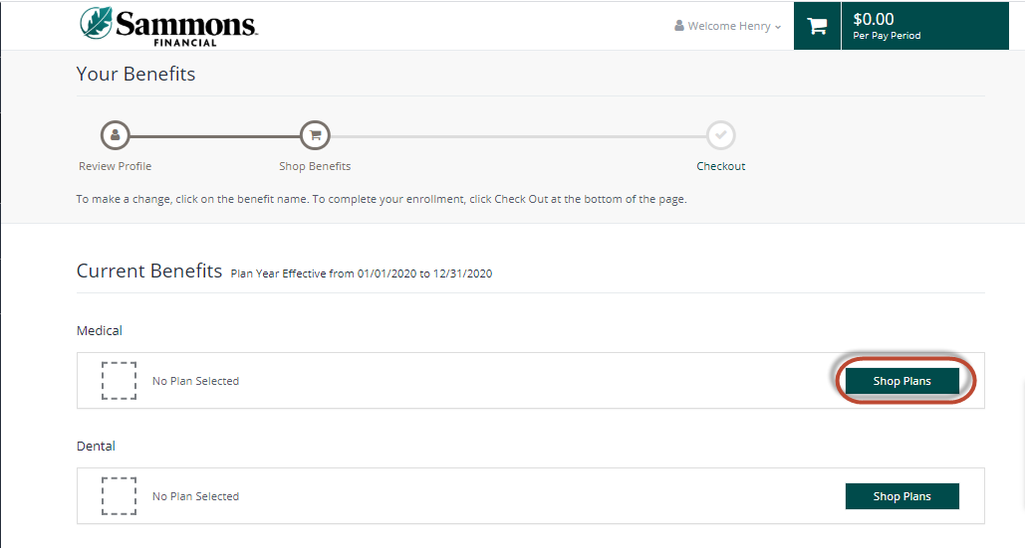

1. **Ensure you have all members “checked” that you want covered on each applicable benefit plan.**

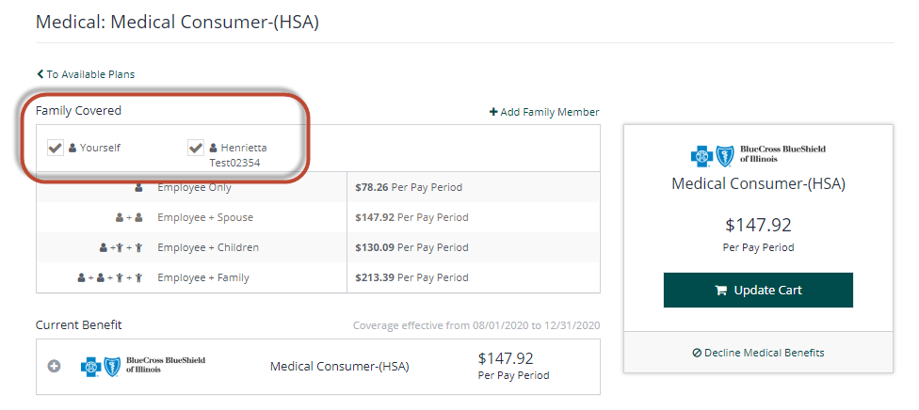

1. Update Cart to update your elections.
2. You will automatically move to the next eligible benefit or survey to complete all elections.
3. Once you complete the shopping experience click, Next: Review Beneficiaries

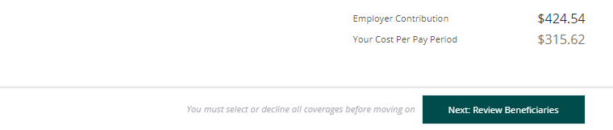

1. You can enter a person, trust or charity as your beneficiary and complete all required fields.

* You can add multiple primary and secondary beneficiaries as you see fit.
* **Optional:** When entering beneficiary details you can click “Add to all benefits” and it will populate the same person and allocation for any other beneficiary plans you need to complete.
* Once beneficiaries are complete the ‘Review and Checkout’ will turn green for you to click

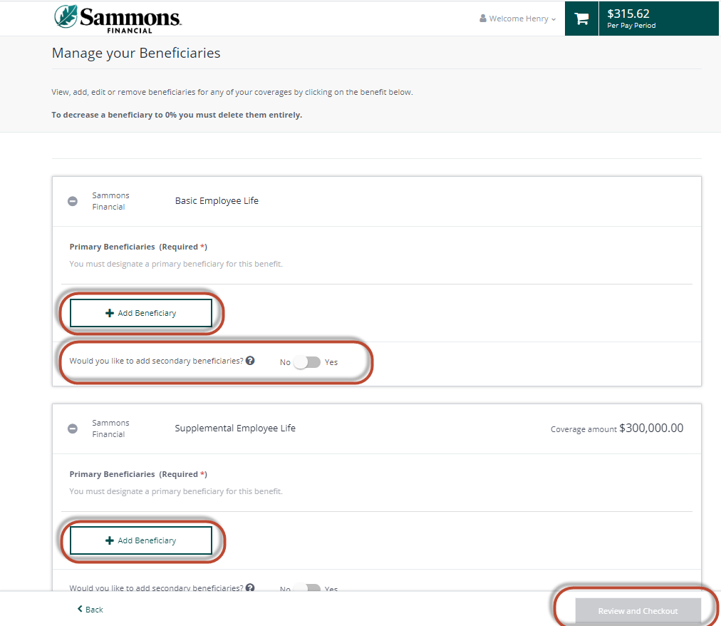

1. Review your benefit selections. Once satisfied click, “Checkout.”
2. You then receive the below confirmation page. You can email your elections to yourself.

**ACTION:** Review if you have a **required** To-Do List of item(s) that require an upload

You’ll be able to upload needed items now, or at a later date – within 31 days of event.

**Your benefit elections are complete!**

